Johnston Girls Little League
Softball Association

Safety Manual

for
Managers, Coaches, and Volunteers

2024

League # 311368
Table of Contents
Letter from the JGSA Board………………….........................................................................  ASAP Mission Statement......................................................................................................  Emergency Phone Numbers………………………………………………………………………  Safety Code..........................................................................................................................  Volunteer Guidelines..................................................................................................  Equipment..................................................................................................................  Accidents....................................................................................................................  Training......................................................................................................................  Fields & Grounds…………………………………………………………………………...  Games & Practices…………………………………………………………………………  Weather……………………………………………………………………………………...  Batting Cages……………………………………………………………………………….  Miscellaneous………………………………………………………………………………  Pregame Checklist………………………………………………………………………………….  Code of Conduct...................................................................................................................  Accident Reporting Procedures............................................................................................  Incident/Injury Tracking Report.............................................................................................  Concession Stand Safety......................................................................................................  Basic First Aid.......................................................................................................................  Communicable Disease Prevention...........................................................................  Injury Do’s and Don’ts................................................................................................  Concussions...............................................................................................................  Heat Related Illness...................................................................................................  Sprains & Strains........................................................................................................  Broken Bones.............................................................................................................  Cuts…………………………………………………………………………………………..  Field Map……………………………………………………………………………………………. | 3  4  4  4  5  5  5  5  6  6  6  7  7  7  8  9  10  10  12  12  12  12  14  15  16  17  18  19

Dear Coaches, Parents, and Players:

Welcome to another exciting season of Johnston Girls Softball. JGSA is beginning our fifth year as part of the national Little League Softball program. In 1994, Little League developed a new initiative called A Safety Awareness Program (ASAP) to raise awareness of safety issues and allow leagues to take their own approach to safety implementation. Since the implementation of ASAP by Little League, there has been an overall decline in injuries to kids/participants. Severity of injuries has also been reduced by 80%.

In accordance with Little League recommendations and in an effort to attain and maintain the highest standards of safety, the JGSA Board of Directors has created the board position of safety officer and developed the following safety action plan. Please take the time to review this manual carefully and do not hesitate to forward any concerns or questions to our league safety officer, league president, or any other JGSA board member.

In the event that any item within this manual conflicts with any Little League, State and/or Federal law and/or guideline; the appropriate Little League, State and/or Federal law and/or guideline will take precedence.

Let’s play ball!

The JGSA Board

The ASAP Mission:
To increase awareness of the opportunities to provide a safer environment for kids and all Little League participants.

Emergency Phone Numbers

Emergency Phone Number: 9-1-1
Local Police Department: 515-278-2345
Local Fire Department: 515-276-5182
JGSA Safety Officer: Gina Beals 515-669-5910
JGSA President: Morgan Halverson 515-451-6906
JGSA Vice President: Jamie Lewton 515-777-0221
JGSA Facilities Officer: Dusty Sowers 515-468-7847
Eric Clark 515-202-1563
District 3 Administrator Chris Chadd 515-419-7599
District 3 ADA Safety Officer Matt Buman 515-979-4230

Hospitals:
Mercy Main 1111 6th Avenue, Des Moines, IA 515-247-3121
Mercy West Lake 1755 59th Place, West Des Moines, IA 515-358-8000
Iowa Methodist/Blank Children’s 1200 Pleasant Street, Des Moines, IA 515-241-6212
Methodist West 1660 60th Street, West Des Moines, IA 515-343-1000
Broadlawns 1801 Hickman Road, Des Moines, IA 515-282-2200

Safety Code
Volunteer Guidelines
- All JGSA board members, coaches, and other volunteers will complete the annual Little League Volunteer form and be subject to a background check annually per Little League guidelines.
- No adult volunteer is permitted to be alone with any child unless they are a first-degree relative.
- Each year, a member of the board shall be designated the League Safety Officer. The League Safety Officer for the 2023-2024 term is Gina Beals.
Phone: 515-669-5910
Email: gibeals91@gmail.com
A copy of the safety manual will be distributed to all league volunteers including board members and coaches. A copy will also be located in the Quad shed, and in the dugout closets of Merical, VanDees, and Signarama fields.
- There will be at least one officer of the day assigned during all regular season practices and games.
- All volunteers will be required to abide by the JGSA code of conduct as outlined on Page 9 of this manual.

Equipment
- Equipment will be inspected by the Equipment and Uniform Director prior to each season and by the coach and umpire prior to each game. Damaged equipment will be properly disposed of.
- All team equipment should be stored within the team dugout, or behind screens, and not within the area defined “in play”. Responsibility for keeping bats and loose equipment off the field of play should be that of the player responsible for the particular item and/or the team’s manager and coaches.
- Any player catching for a pitcher, whether in practice, warm up, or a game, must wear a catcher’s helmet, mask, throat guard, chest protector, and shin guards. NO EXCEPTIONS.
- Batters must wear Little League approved protective helmets with NOCSAE seal during batting practice and games. Coaches should encourage the use of face guards on batting helmets.
- All bats will conform to Little League standards.
- Shoes with metal spikes or cleats are not permitted. Shoes with molded cleats are permissible.
- Fielding face masks will be required for all girls during games when in any fielding position except for catcher who will be wearing the required catching helmet.

Accidents
- Responsibility for Safety procedures should be that of all adult members of the Johnston Girls Softball Association including board members, coaches, and other volunteers.
- Report all accidents and near misses. Injury and Accident reporting may be performed by any league volunteer, parent, or player that witnesses an injury or accident. The report should be made to the Safety Officer or JGSA officer of the day within 48 hours of the incident. See Page 10 of this manual for further guidelines and instructions on accident reporting. Page 11 contains an accident reporting form that may be used to initially report any incident.
- A working telephone should be available at all JGSA events including all games, practices, and other organization events.
- First-Aid Kits are issued to all teams during the initial equipment distribution. Teams are required to have First-Aid Kits at all practices and games. There is an AED available at the concession stand. Any time the AED is needed, 911 should also be called.
- At no time should “horse play” be permitted within Lew Clarkson Park.

Training
- Safety and First-Aid training and Fundamental Skills training will be provided at the start of each season.
- A coach from each team must attend JGSA’s First-Aid Training Seminar. Each individual coach must attend the Safety and First-Aid Training at least once every three years.
- Coaches are encouraged to complete the online concussion training, heads Up Coaches: Concussion in youth Sports, at https://headsup.cdc.gov/.
- A coach from each team must attend JGSA’s Fundamental Skills Training Seminar. Each individual coach must attend the Fundamental Skills Training at least once every three years.
- All coaches will receive a list of any special medical needs for the players on their team prior to the start of the season.
- All board members and coaches will be required to review and familiarize themselves with this safety manual.

Field & Grounds
- The JGSA Safety Officer will complete the Facility Survey annually.
- Coaches and umpires will walk and inspect their assigned field prior to practices and games. See Coaches Checklist on page 8.
- After each game, coaches should ensure dugouts and areas around the outside of the playing area are free of trash and dangerous objects.
- Report any potential safety hazards and/or repairs to the Facility Coordinator for immediate repair.
- Motorized field equipment should not be used by those under the age of 16 without adult supervision.

Games & Practices
- Only players, coaches, and umpires are permitted on the playing field or in the dugout during games and practice sessions.
- Players in the dugout should remain behind the fence and not in the dugout doorway.
- All pre-game warm-ups should be performed within the confines of the playing field and not within areas that are frequented by spectators (i.e., playing catch, pepper, swinging bats, etc.).
- During warm-up drills players should be spaced so that no one is endangered by wild throws or missed catches.
- While on the playing field, all players should be alert and watching for thrown and batted balls and players swinging bats.
- Parents of players who wear glasses should be encouraged to provide “safety glasses”.
- Player must not wear watches, rings, pins or metallic items during games and practices.
- Coaches may not warm up pitchers before or during a game.
- On deck batters are not permitted. Players may not pick up a bat until it is their turn to enter the batting box.
- All gates to the field must remain closed at all times. After players have entered or left the playing field, gates should be closed and secured.

Weather
- No games or practices should be held when weather or field conditions create an unsafe environment.
- There is a lightning detector located in the north concession stand. The lightning detector shall be turned on before the first game of the day and remain on until the park is closed. If lightning is detected within the 3-8 mile range or less, all persons will be required to vacate Lew Clarkson Park. Once play is suspended, there is a wait period of at least 30 minutes after the last flash of lightning is witnessed, thunder is heard, or the detector indicates lightning in the 3-8 mile range, before play can resume. An Officer of the Day will make the final decision pertaining to when play can resume or if field conditions are unsafe to continue play.
- No games or practices should be held when there is an active tornado warning for Johnston, IA.

Batting Cages
- Batting helmets are required while batting in the cages.
- Only one batter and one pitcher is permitted in the cage at one time.
- L-screens should be used at all times to protect the pitcher within batting cages

Miscellaneous
- Player registration data and coach data will be submitted to Little League via the data center annually.
- Children should be supervised while playing on the playground equipment.
- The speed limit for the roads and parking lots within Lew Clarkson park is 5mph. Watch for small children around parked cars.
- Observe all posted signs. Players and spectators should be alert at all times for Foul Balls and Errant Throws.
- All concession stand instructions and safety procedures will be posted within the concession stand. These can be viewed on pages 12-17 of this manual.
- Any pets brought to the games must be under direct control of the owner and on a leash or other restraining device. Owner must clean up after pets.
- No medication will be administered to any player unless done so directly by the child’s parent. This includes aspirin, Tylenol or ibuprofen.
- No alcohol or drugs are allowed within Lew Clarkson Park at any time.

Coach Pregame Checklist

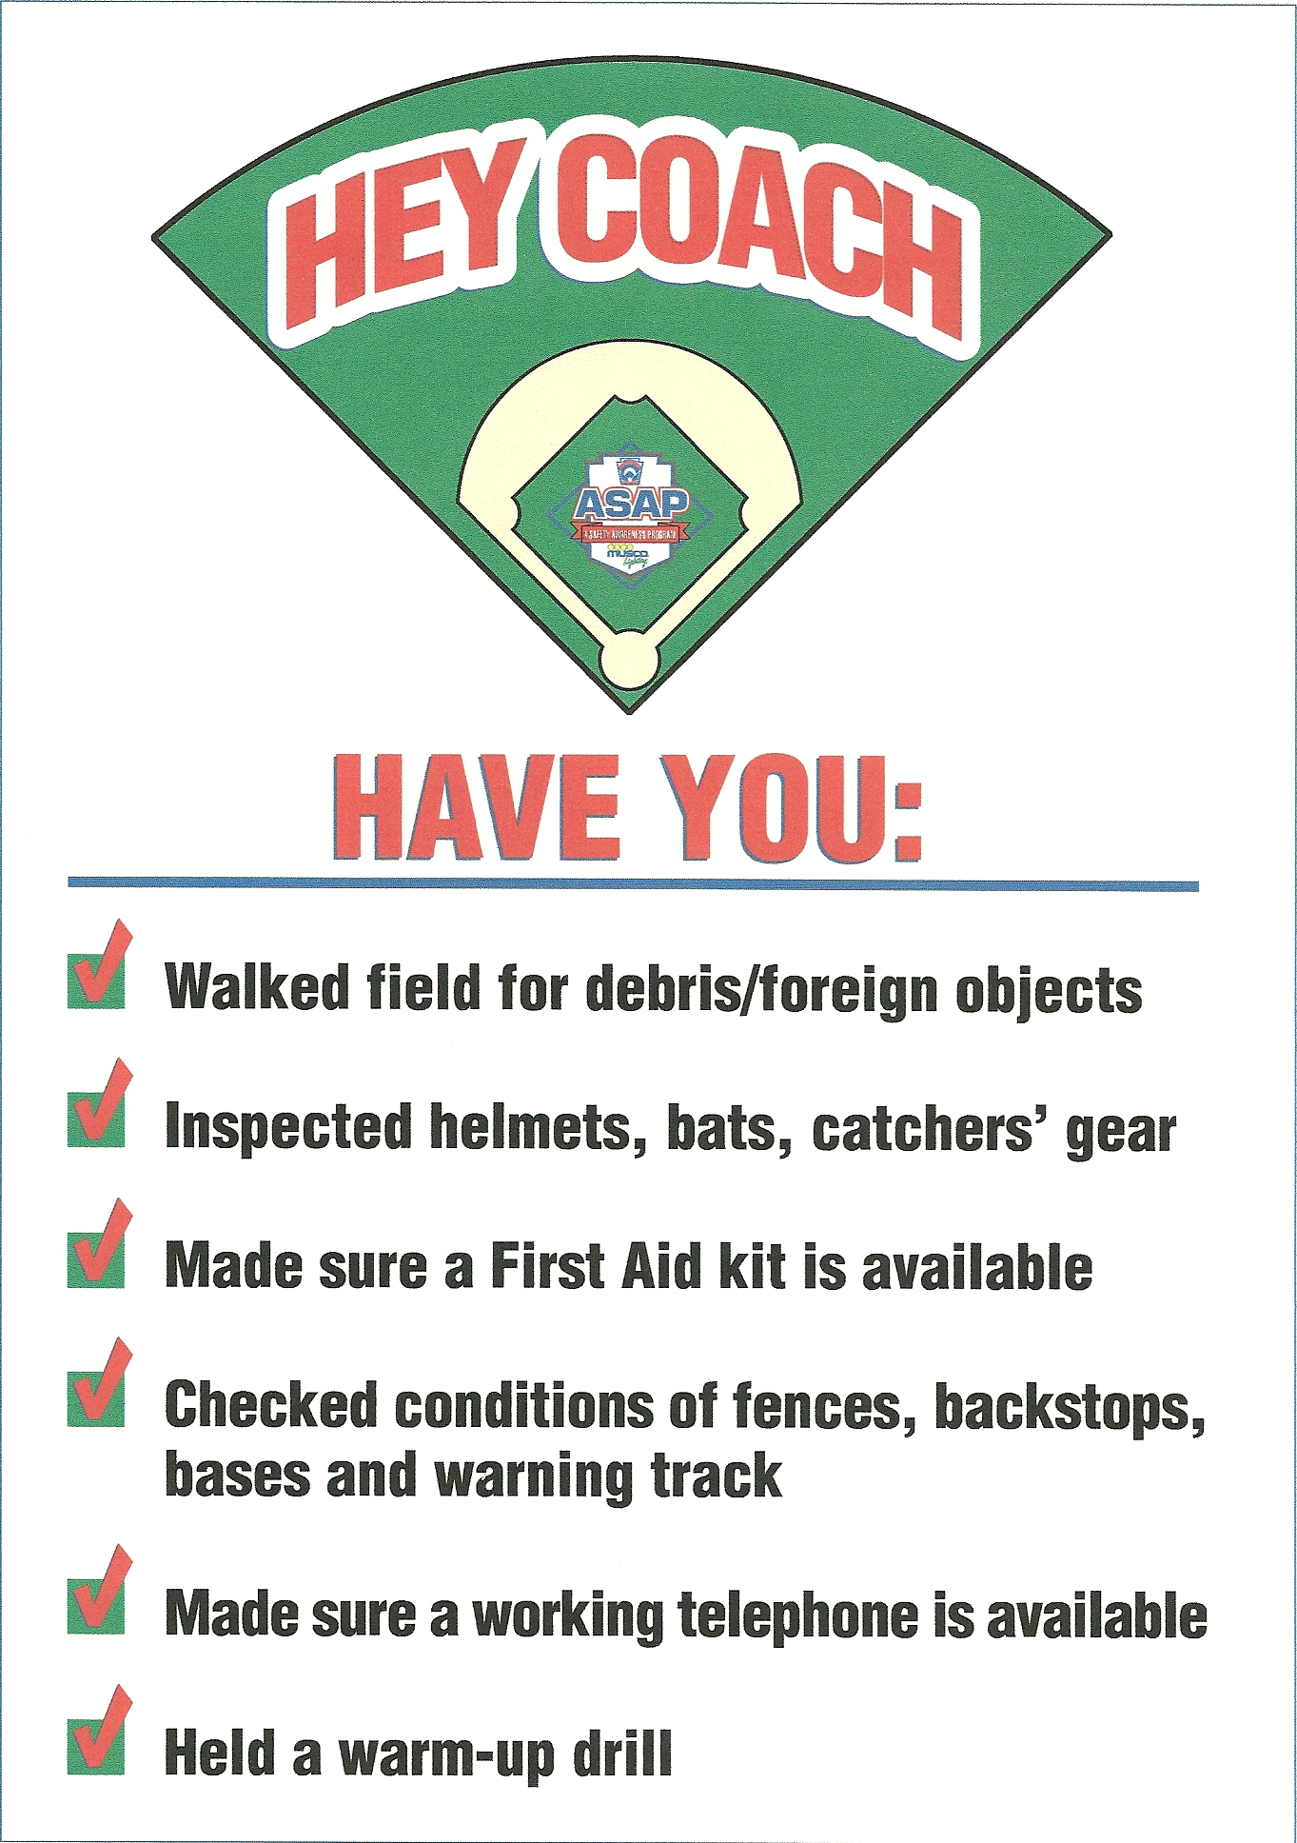

Code of Conduct

The board of directors of Johnston Girls Softball Association has mandated the following Code of Conduct. All coaches, board members, and volunteers will familiarize themselves with this Code of Conduct and agree to abide by its contents.

Johnston Girls Softball Association Code of Conduct:

No Board Member, Coach, Player or Spectator shall:

- At any time lay a hand upon, push, shove, strike, or threaten to strike an official, player, coach, manager, or spectator.
- Be guilty of personal verbal or physical abuse upon any official for any real or imaginary belief of a wrong decision or judgment.
- Be guilty of an objectionable demonstration of dissent at an official’s decision by throwing of gloves, helmets, hats, bats, balls, or any other forceful unsportsmanlike action.
- Be guilty of using unnecessarily rough tactics in the play of a game against the body of an opposing player.
- Be guilty of a physical attack upon any board member, official manager, coach, player or spectator.
- Be guilty of the use of profane, obscene or vulgar language in any manner at any time.
- Appear on the field of play, stands, or anywhere on the Lew Clarkson complex while in an intoxicated state at any time.
- Be guilty of gambling upon any play or outcome of any game with anyone at any time.
- Use tobacco products of any kind within Lew Clarkson park.
- Be guilty of discussing publicly with spectators in a derogatory or abusive manner any play, decision, or a personal opinion on any players during the game.
- Speak disrespectfully to any parent, player, coach, official or representative of the league.
- Be guilty of tampering or manipulation of any league rosters, schedules, draft positions or selections, official score books, rankings, financial records or procedures.
- Challenge an umpire’s authority. The umpires shall have the authority and discretion during a game to penalize the offender according to the infraction up to and including removal from the game.

The JGSA Board of Directors will review all infractions of the JGSA Code of Conduct. Depending on the seriousness or the frequency of the offense, the board may assess additional disciplinary action up to and including expulsion from the association.
Accident Reporting Procedures

What to report - An incident that causes any player, manager, coach, umpire, or volunteer to receive medical treatment and/or first aid must be reported to the Safety Officer. This includes even passive treatments such as the evaluation and diagnosis of the extent of the injury or periods of rest.

When to report - All such incidents described above must be reported to the Safety Officer within 48 hours of the incident. The Safety Officer for 2024 is Gina Beals. Who can be reached at the following:

Phone: 515-669-5910
Email: gibeals91@gmail.com

How to make the report - Reporting incidents can come in a variety of forms. Most typically, they are telephone conversations. At a minimum, the following information must be provided:
- The name and phone number of the individual involved
- The date, time, and location of the incident
- As detailed a description of the incident as possible
- The preliminary estimation of the extent of any injuries
- The name and phone number of the person reporting the incident

Incident/Injury Tracking forms are available at the concession stand and in the Quad shed, on page 11 of this manual, or at this website (http://www.littleleague.org/Assets/forms_pubs/asap/Injury_Tracking_Form.pdf)
and may be utilized as the initial reporting mechanism. A witness to the event can fill out the form and forward it to the League Safety Officer.

Safety Officer’s Responsibilities - Within 48 hours of receiving the incident report, the Safety Officer will contact the injured party or the party’s parents and (1) verify the information received; (2) obtain any other information deemed necessary; (3) check on the status of the injured party; and (4) in the event that the injured party required other medical treatment (i.e., Emergency Room visit, doctor’s visit, etc.) will advise the parent or guardian of the JGSA’s insurance coverage and the provisions for submitting any claims.
If the extent of the injuries are more than minor in nature, the Safety Officer shall periodically call the injured party to (1) check on the status of any injuries, and (2) to check if any other assistance is necessary in areas such as submission of insurance forms, etc. until such time as the incident is considered “closed” (i.e., no further claims are expected and/or the individual is participating in the league again).

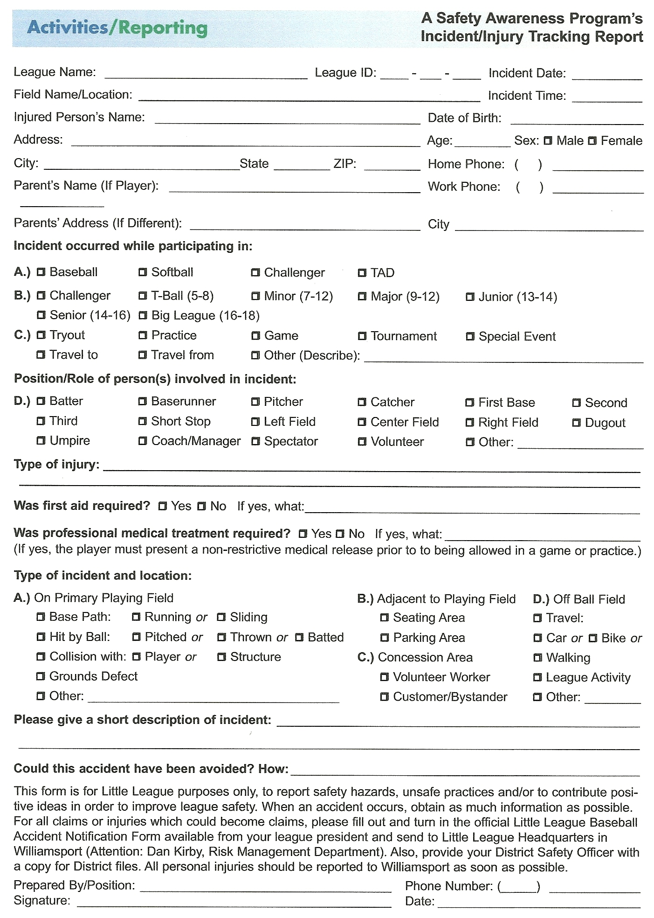

Concession Stand Safety
- Two concession stands exist on Lew Clarkson property. Both are 100% run by a third party. All safety and licensing and food inspections are the responsibility of the third party.
- No volunteers or athletes are allowed inside the concessions stands.
- Concessions will be open during all games.

Basic First Aid - Communicable Disease Prevention

- When an athlete has an injury involving blood, the bleeding must be stopped, the open wound covered, and the uniform changed if there is blood on it before the athlete may return to play.
- Using gloves to prevent contact with blood or other body fluids is recommended.
- Immediately wash hands and other skin surface if contaminated with blood.
- Any surfaces or equipment that are contaminated with blood should be cleaned and disinfected.
- Umpires, coaches, and volunteers with open wounds should refrain from direct contact with any player until the condition is resolved.

Basic First Aid – Injury Do’s & Don’ts

Do...
- Reassure and aid children who are injured, frightened, or lost.
- Provide, or assist in obtaining, medical attention for those who require it.
- Know your limitations.
- Carry your first-aid kit to all games and practices outside of the Lew Clarkson complex.
- Assist those who require medical attention - and when administering aid, remember to:
  - LOOK for signs of injury (Blood, bruising, deformity, etc.).
  - LISTEN to the injured describe what happened and what hurts if conscious. Before questioning, you may have to calm and soothe an excited child.
  - FEEL gently and carefully the injured area for signs of swelling or grating of broken bone.
- Plan to have a cellular phone available at all games or practices.

Don’t...
- Administer any medications including Tylenol or ibuprofen.
- Hesitate in giving aid when needed.
- Be afraid to ask for help if you’re unsure of the proper procedures (i.e., CPR, etc.).
- Transport injured individuals except in extreme emergencies. Transportation should be provided by a parent or guardian or emergency medical personnel.
- Leave a child unattended at a practice or game.
- Hesitate to report any present or potential safety hazard to the Safety Officer or any other board member immediately.

Basic First Aid - Concussions

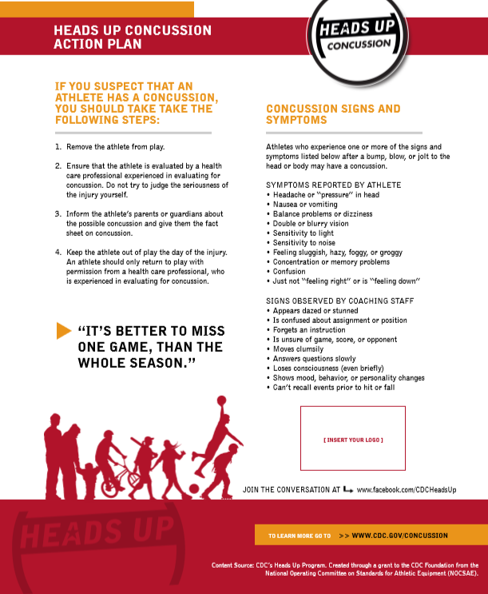

Basic First Aid – Heat Related Illness
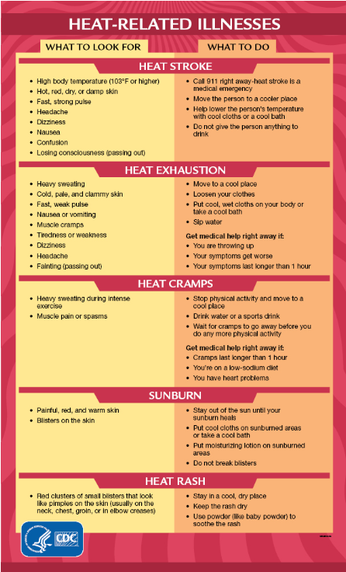

Basic First Aid – Sprains & Strains
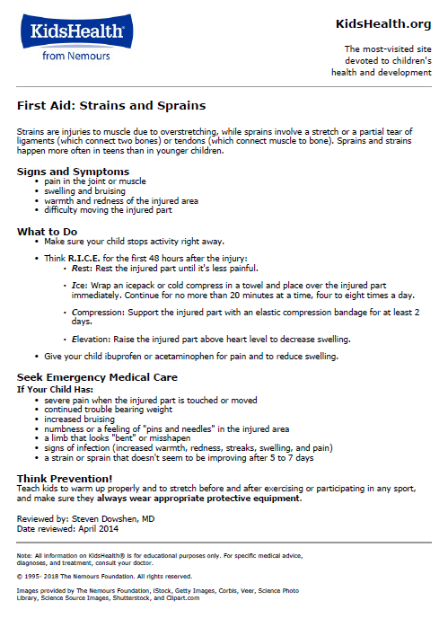

Basic First Aid – Broken Bones
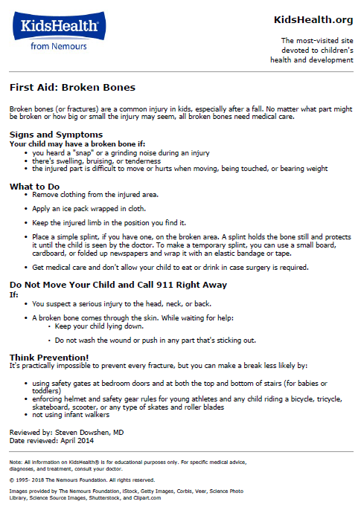

Basic First Aid – Cuts
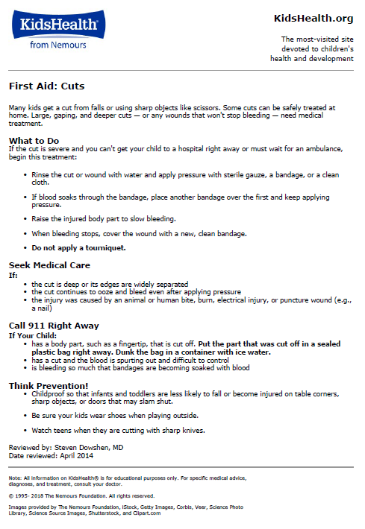

Map of Lew Clarkson Park

